Quality Indicator Statuses
The Quality Indicator Program utilises the following status definitions that should be relayed to the consumer and match what would normally be seen within the Government Provider Management System (GPMS) when viewing Quality Indicator Submissions:
QI Submission Status | Definition
Not Started | If a collection period has started but a user has not saved as draft or submitted any QI data. (No submissions will be able to be retrieved with this status via the API)
In Progress | If a collection period has started and a submission draft has been created but not finalised.
Submitted | If a user has submitted data within the submission period.
Late Submission | If a user has submitted data after the submission period has ended.
Submitted - Updated after Due Date | If a user has submitted data during the period then submits a change after the period has ended.
Not Submitted | If a collection period has ended and no submission was finalised for that reporting period.
As the QI API aims to conforms to the FHIR schema. The values for the status field are mapped to the relevant Quality Indicator status as follows:
GET Questionnaire Response:
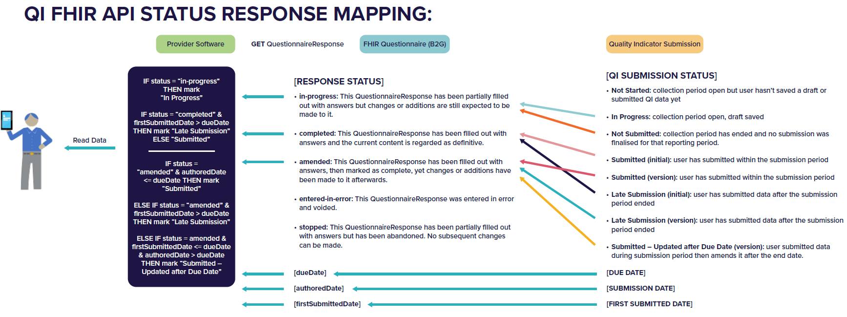
POST/PATCH Questionnaire Response:
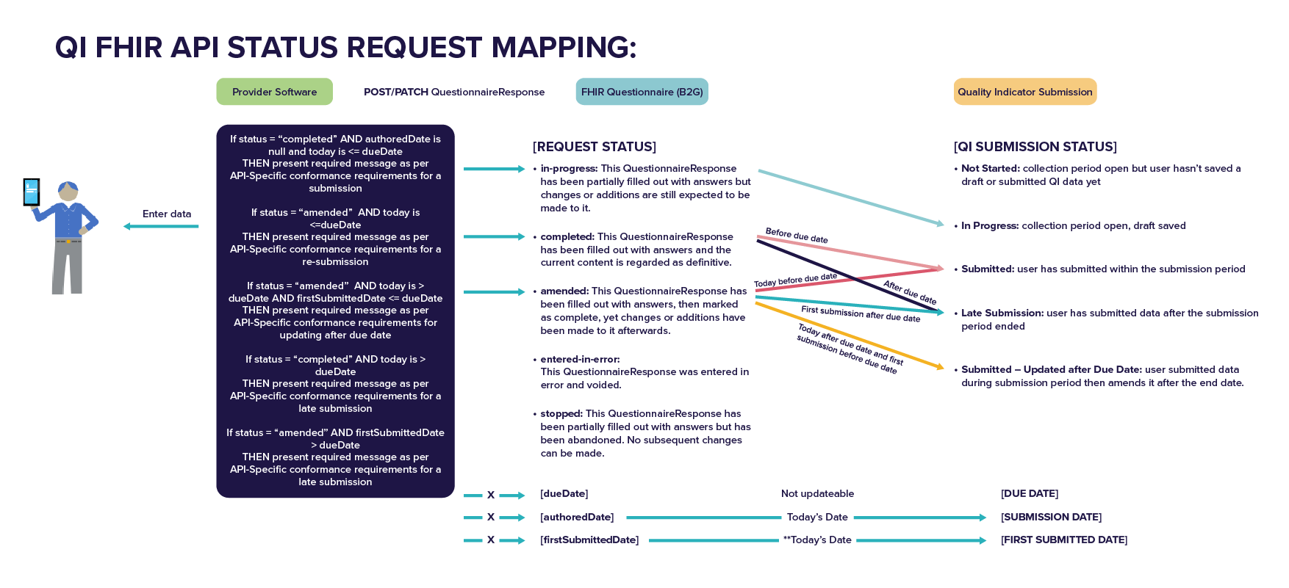
Quality Indicator Submission Lifecycle
The diagram below depicts the lifecycle of a QI Submission and how it will need to be represented for both the QI status and FHIR status:
